Mantid
PM report to Project Management Board
12th June 2018
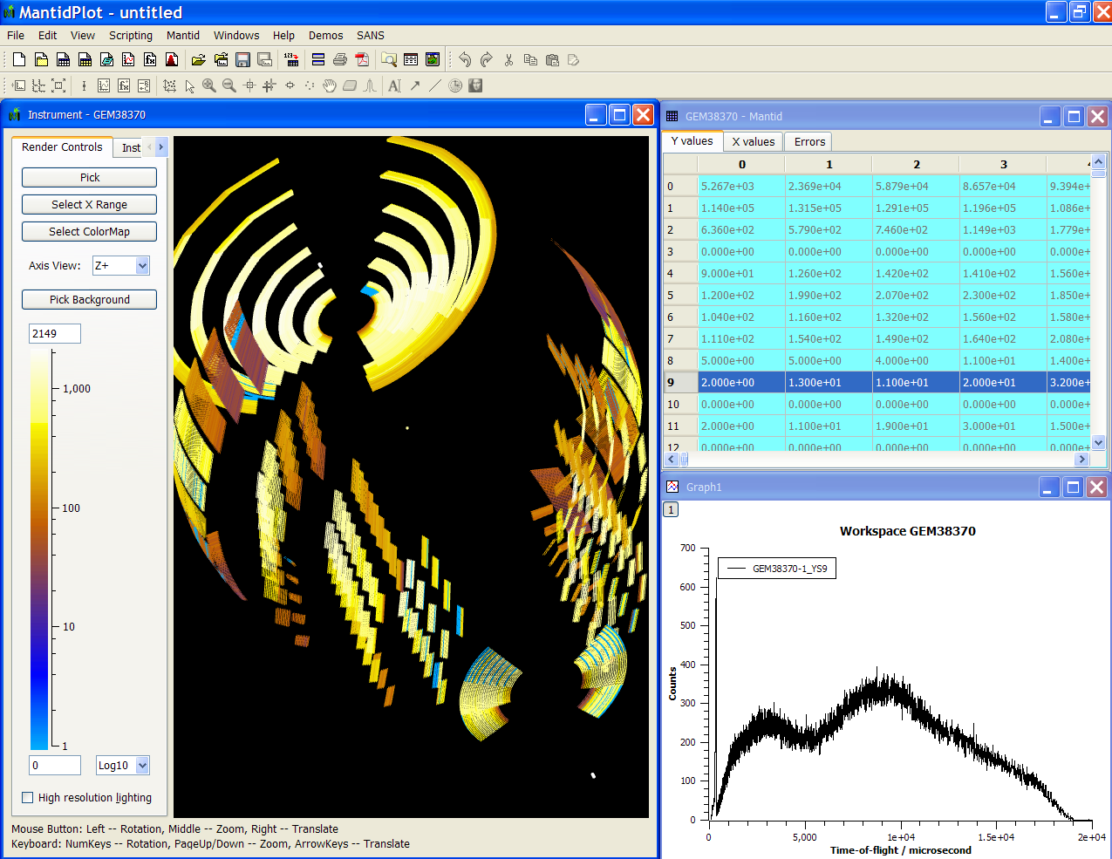
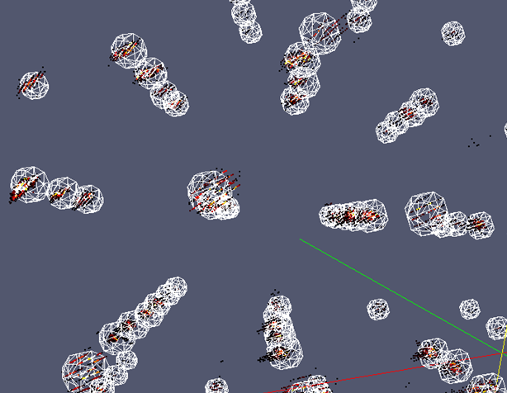
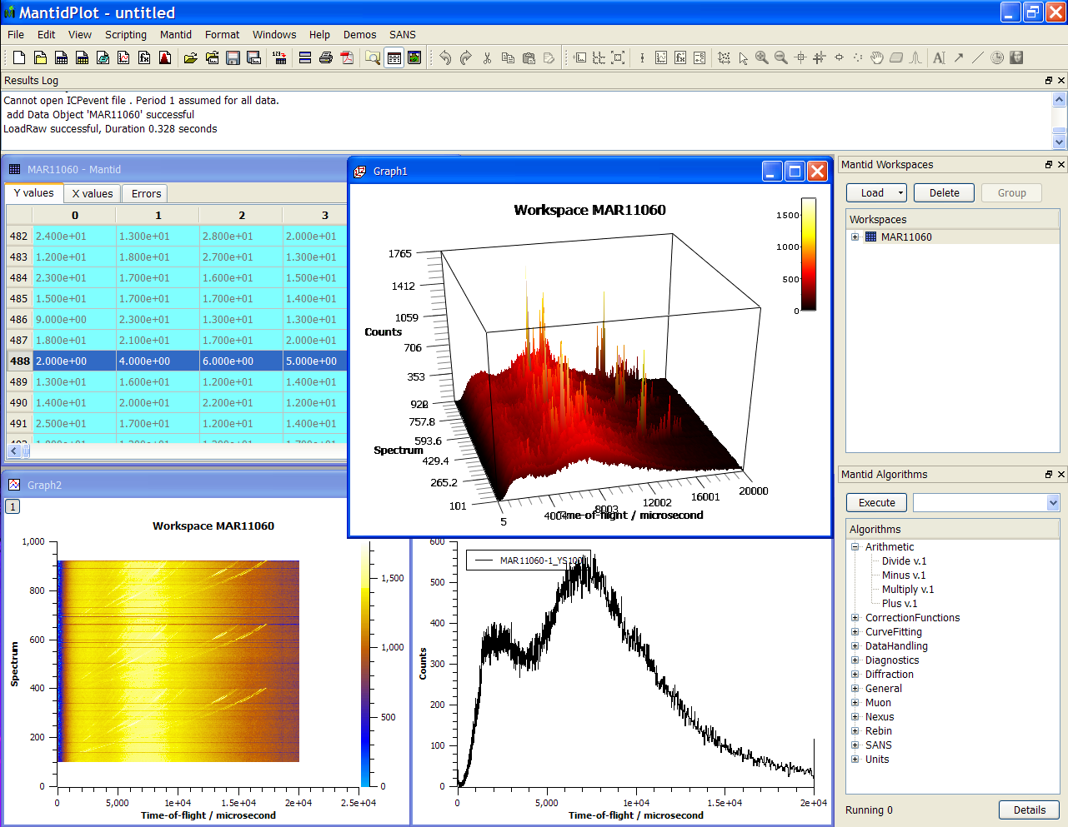
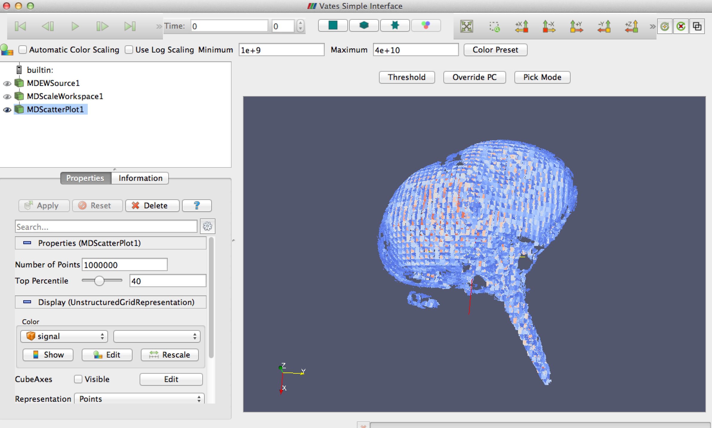
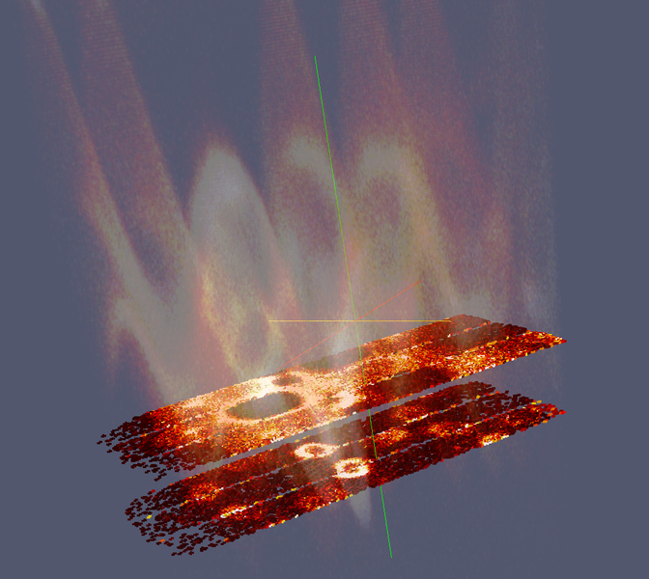
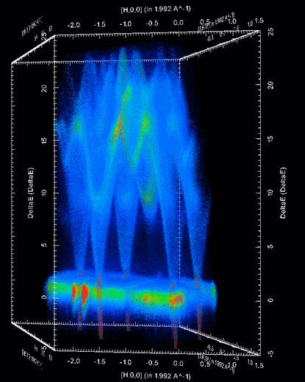

Document Control
This document is under document control. All members of the distribution list will receive updated copies whenever alterations are made. All other copies are uncontrolled.

Contributors
Name | Role | Company
Nicholas Draper | Author | Tessella

Document Approval
Name | Role | Company

Distribution
Name | Role | Company
Project Management Board Members | Recipient | Mantid Partnership
Mantid Project Repository | Filing | Mantid Partnership

Revision History
Author | Issue | Date | Description
Nicholas Draper | V1.R1.M0 | 06-June-2018 | 1st version written

References
Document | Ref | Date | Details and Version
Project Specification | [PS] |  | https://github.com/mantidproject/documents/blob/master/Project%20Management/ProjectSpecification.doc?raw=true
Stakeholder Plan | [SP] |  | https://github.com/mantidproject/documents/blob/master/Project%20Management/StakeholderPlan.doc?raw=true
Risk Register | [RR] |  | https://github.com/mantidproject/documents/blob/master/Project%20Management/RiskRegister.xls

Table of Contents
1 Introduction 3
2 Project Documentation 4
3 Project Status 4
4 Usage of Mantid in various Environments 5
5 Future Release Dates 5
6 Core Team 5
7 Progress on Mantid 4.0 6
8 Appendix A: Metrics 7

Introduction

Purpose of this Document
This report details the current state of the Mantid project. The project management board will use this report as an item for discussion at the meeting.

Scope of this Document
The scope of this document is limited to the Mantid project, both for progress up to the meeting of the Project management board, and plans for the future.

Project Documentation
The project documentation is available through the links below. The documents have not been changed since the last PMB meeting.

Stakeholder Plan:
https://github.com/mantidproject/documents/blob/master/Project-Management/Stakeholder%20Map.doc?raw=true
Reviewed, No changes this time.

Risk Register:
https://github.com/mantidproject/documents/raw/master/Project-Management/RiskRegister.xls
Reviewed, No changes this time.

Project Status

Development Progress
Since the last PM report we have released the following new version of Mantid:

- Release 3.12 – 20th March 2018
- Release 3.12.1 – 23rd April 2018

The releases were made on time according to plan.
The patch release 3.12.1 was driven primarily due to some issues in the Muon interface that prevented that group from being able to use 3.12.0, but also included some other important bug and stability fixes.

The next release 3.13 is planned for the 23rd of July, with the following release plan:
- Code Freeze: 29th June
- Beta Test: 3rd-17th July
- Release: 23rd July

Development for this release has been going well, but we have been somewhat affected by people taking early summer holidays, and expect further disruption during the release period as that coincides with several summer students joining and the cross over period for our sandwich students.

The project metrics in Appendix A.

Usage of Mantid in various Environments
We currently fully support the following environments:
- RHEL 7 64bit
- Windows 7+ 64 bit
- Ubuntu 14.04 64 bit
- Ubuntu 16.04 64 bit
- OS X 10.10+
Limited Support:
- Fedora 20
- Ubuntu 16.04 64 bit

Current Usage:
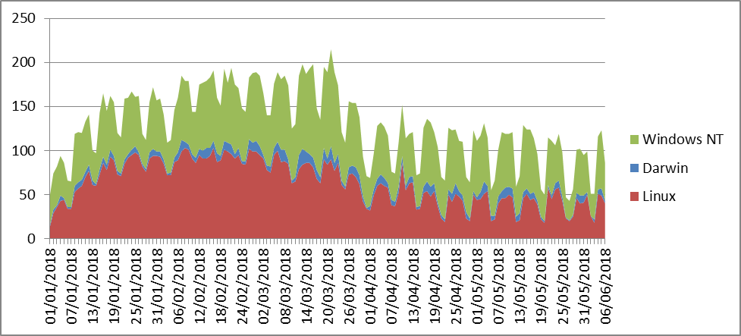

We average around 125 to 175 unique users per weekday, and around 50 – 100/day on weekends. Interestingly our highest usage was during January and February when less facilities were running, possibly scientists were taking the opportunity to analyse data?
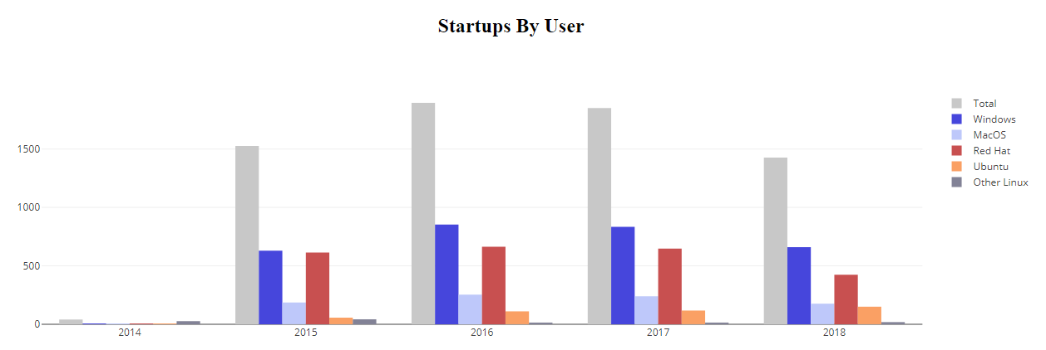
This graph shows the unique user count per year, the 2018 numbers look depressed as it is not adjusted for the partial year, I would expect them to be comparable with previous years by the year end.

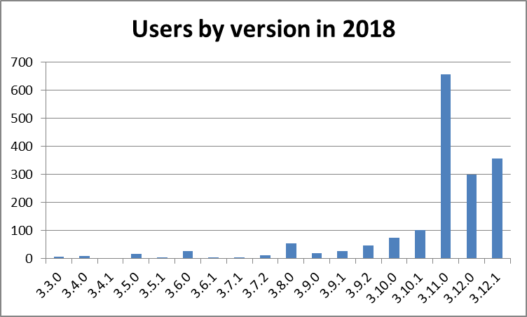
This is a view of the number of users that have used differenct versions of Mantid so far in 2018, Version 3.11.0 was the current version for the first 4 months of the year, so you expect it to the in the lead, the v3.12 and it’s patch version have also been adopted well. We have a significant tail of old versions, this is not a problem per se as long of the users of those versions do not need active support. Given the approach of visiting scientists leaving with a locally installed version then this is to be expected as they are unlikely to upgrade from the version that works for them.

Error Reporting
In release 3.12 we introduced error reporting, so we have results so far from this version and it’s patch version. Just considering the stable releases (so no nightly builds) we have recorded 121 crashes so far. Following up on these issues has led to 3 bugs being fixed and reported to back to the affected users. It is not possible from the data we currently capture to identify how many of the crashes that these 3 bugs accounted for.
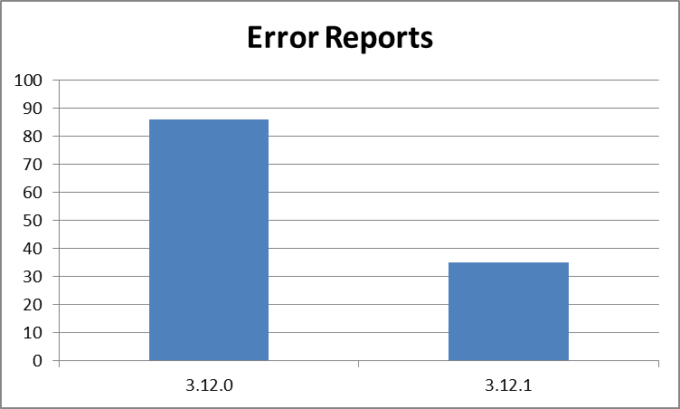
The split between the current releases shows a move downwards in the number of crashes in the patch over the previous release. Of course you need to consider how much each version is used to normalise the values, but given the number of users for the patch has been higher so far then this only further supports this difference.

The next version of error reporting that will be included in release 3.13 will catch more types of crashes, specifically those terminal crashes and times when the user kills the process. This might increase the overall numbers but we should be able to separate out the two types.

Future Release Dates
Proposed dates:
- v3.15 1st April 2019
- v3.16 22nd July 2019

Progress on Mantid 4.0
This gannt chart has been updated with progress to date.

The primary changes are:
- The plan has been adjusted to take into account changes in resource availability:
  - Roman has been redirected to help with reflectometry
  - The last release and maintenance too more of Martyn’s time than was anticipated
- We are aiming on delivering a first version to instrumentment scientists with Mantid v3.14 (December 2018), this is unlikely to be feature complete, but aimed to allow some techniques to adopt it.
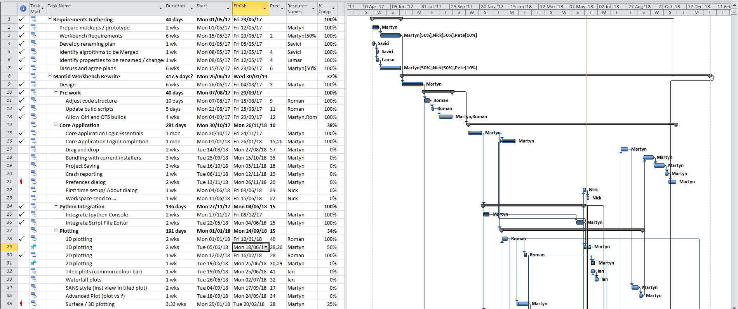

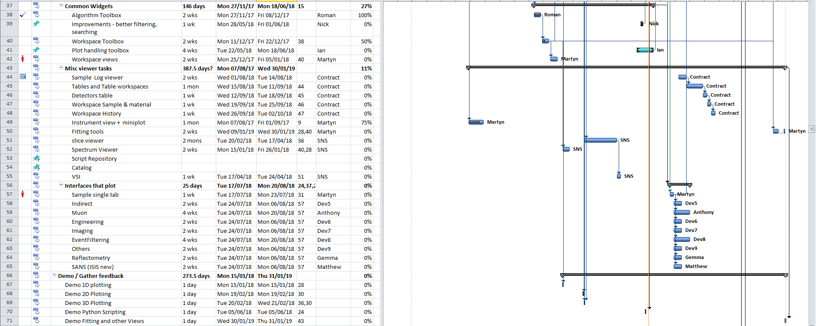

Appendix A: Metrics

Project Metrics
The code metrics are independently generated and displayed here
http://www.openhub.net/p/Mantid/analyses/latest/languages_summary

Total Lines : | 2,307,086 |  | Code Lines : | 1,649,290 |  | Percent Code Lines : | 71.5%
Number of Languages : | 17 |  | Total Comment Lines : | 360,185 |  | Percent Comment Lines : | 15.6%
 |  |  | Total Blank Lines : | 297,611 |  | Percent Blank Lines : | 12.9%

Code, Comments and Blank Lines
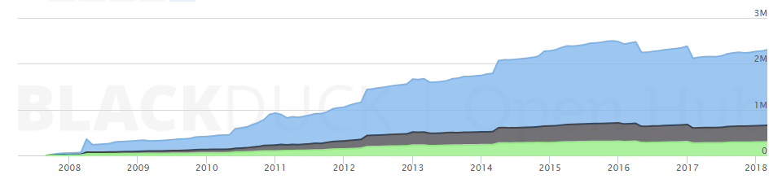
Code
Comments
Blanks

In a Nutshell, Mantid...
- has had 88,085 commits made by 135 contributors representing 1,649,041 lines of code
- is mostly written in C++ with an average number of source code comments
- has a well established, mature codebase maintained by a very large development team with stable Y-O-Y commits
- took an estimated 471 years of effort (COCOMO model) starting with its first commit in April, 2007

